Name: B C Yugesh Reg no: 192424282
Course code: DSA0604
Class Activity (20/07/2026)

Scenario 1: Hospital Patient Admission Analysis
library(ggplot2)
department <- c("Cardiology","Neurology","Pediatrics","Orthopedics","Emergency")
admissions <- c(120,95,150,110,180)
data <- data.frame(department, admissions)
print(data)
barplot(admissions,
names.arg=department,
col="skyblue",
main="Patient Admissions by Department",
xlab="Department",
ylab="Admissions")
pie(admissions,
labels=department,
col=rainbow(5),
main="Department-wise Admissions")
hist(admissions,
col="lightgreen",
main="Admissions Distribution",
xlab="Admissions")
boxplot(admissions,
col="orange",
main="Admissions Box Plot",
ylab="Admissions")
stack <- matrix(admissions, nrow=1)
barplot(stack,
col=rainbow(5),
main="Stacked Bar Chart",
legend.text=department)
symbols(1:5,
rep(1,5),
squares=sqrt(admissions),
inches=0.5,
bg=rainbow(5),
xlab="",
ylab="",
main="Treemap Representation")

Output:
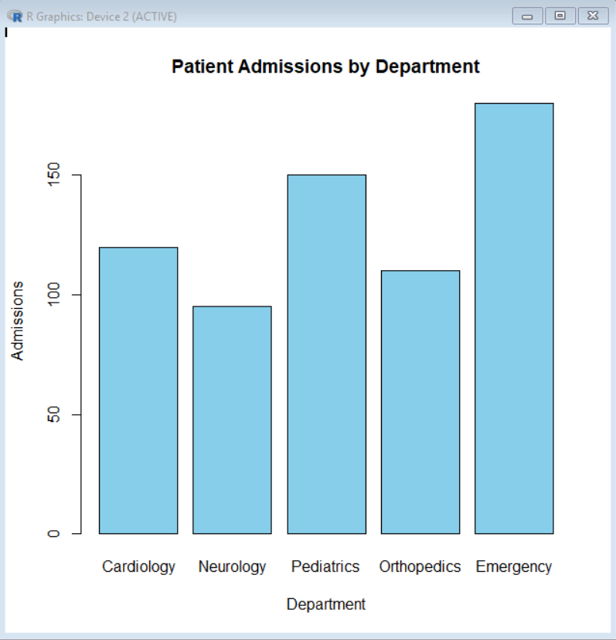

Scenario 2: E-Commerce Customer Spending Behaviour
category <- c("Electronics","Clothing","Electronics","Grocery",
"Clothing","Electronics","Grocery","Clothing")
spending <- c(500,700,450,900,650,800,550,750)
data <- data.frame(category, spending)
print(data)
hist(spending,
col="lightblue",
main="Customer Spending Distribution",
xlab="Spending")
boxplot(spending,
col="orange",
main="Customer Spending",
ylab="Spending")
plot(density(spending),
main="Density Plot",
col="blue",
lwd=2)
total <- tapply(spending, category, sum)
barplot(total,
col=c("red","green","blue"),
main="Category-wise Spending",
xlab="Category",
ylab="Total Spending")
Output:
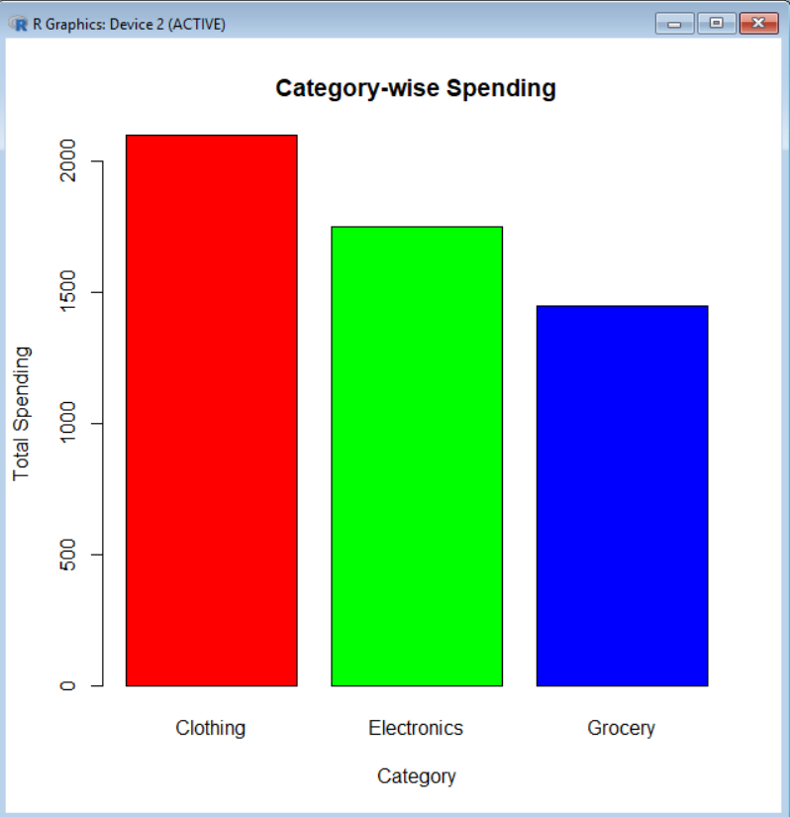

Scenario 3: University Examination Performance Dashboard
subjects <- c("Maths","Physics","Chemistry","English","Computer")
marks <- c(85,78,92,88,95)
data <- data.frame(subjects, marks)
print(data)
barplot(marks,
names.arg=subjects,
col="skyblue",
main="Subject-wise Marks",
xlab="Subjects",
ylab="Marks")
pie(marks,
labels=subjects,
col=rainbow(5),
main="Marks Distribution")
hist(marks,
col="lightgreen",
main="Marks Distribution",
xlab="Marks"
boxplot(marks,
col="orange",
main="Marks Box Plot",
ylab="Marks")
plot(marks,
type="o",
col="blue",
xaxt="n",
main="Marks Trend",
xlab="Subjects",
ylab="Marks")
axis(1, at=1:5, labels=subjects)
Output:
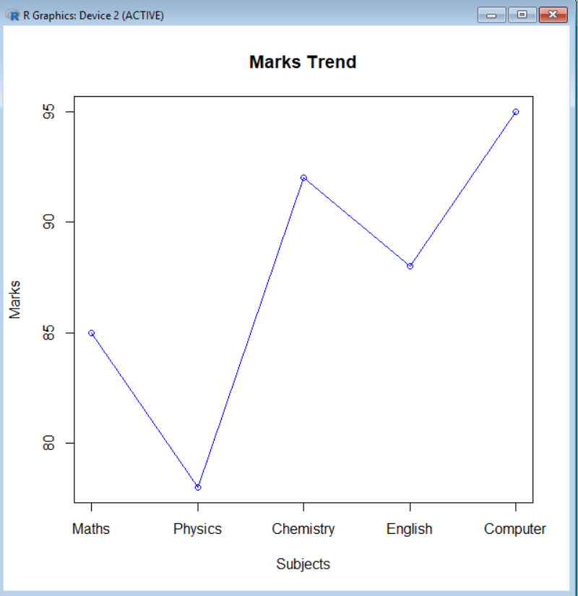

Scenario 4: Climate and Rainfall Distribution Study
months <- c("Jan","Feb","Mar","Apr","May","Jun")
rainfall <- c(45,60,80,120,160,200)
data <- data.frame(months, rainfall)
print(data)
barplot(rainfall,
names.arg=months,
col="skyblue",
main="Monthly Rainfall",
xlab="Months",
ylab="Rainfall (mm)")
plot(rainfall,
type="o",
col="blue",
xaxt="n",
main="Rainfall Trend",
xlab="Months",
ylab="Rainfall (mm)")
axis(1, at=1:6, labels=months)
hist(rainfall,
col="lightgreen",
main="Rainfall Distribution",
xlab="Rainfall (mm)")
boxplot(rainfall,
col="orange",
main="Rainfall Box Plot",
ylab="Rainfall (mm)")
pie(rainfall,
labels=months,
col=rainbow(6),
main="Rainfall Percentage")
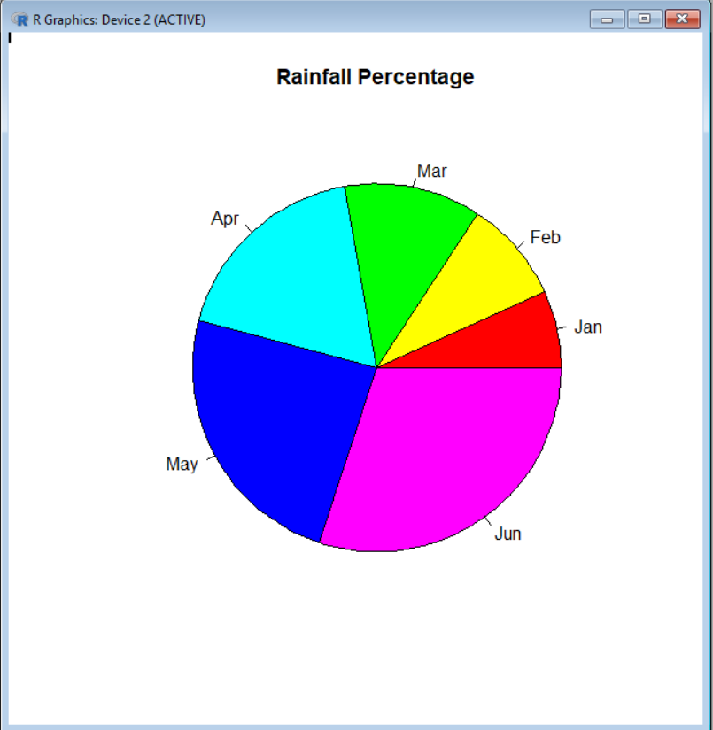
Output:

Scenario 5: Bank Loan Risk Assessment
customer <- c("C1","C2","C3","C4","C5","C6")
loan <- c(50000,75000,60000,90000,45000,80000)
risk <- c("Low","High","Medium","High","Low","Medium")
data <- data.frame(customer, loan, risk)
print(data)
risk_count <- table(risk)

barplot(risk_count,
col=c("green","yellow","red"),
main="Loan Risk Categories",
xlab="Risk Level",
ylab="Number of Customers")
pie(risk_count,
labels=names(risk_count),
col=c("green","yellow","red"),
main="Loan Risk Distribution")
hist(loan,
col="lightblue",
main="Loan Amount Distribution",
xlab="Loan Amount")
boxplot(loan,
col="orange",
main="Loan Amount Box Plot",
ylab="Loan Amount")
dotchart(loan,
labels=customer,
main="Customer Loan Amount",
Output:
